NAME: Mukesh Raj L
REG NO: 192571036

GITHUB
EXPERIMENT - 14
AIM:
Demonstrate how to work collaboratively in Git/GitHub on a project using the fork-and-pull request workflow.
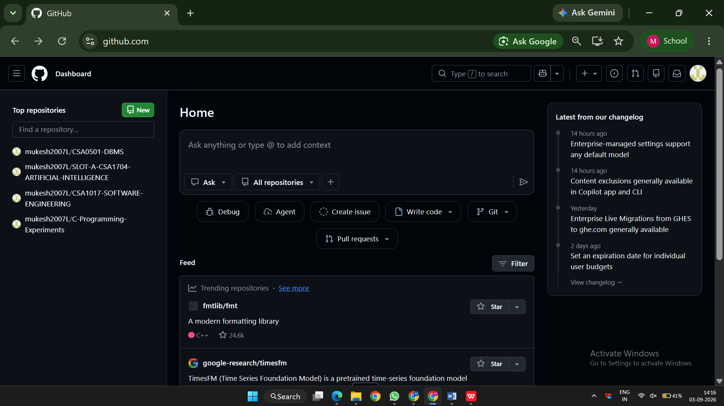
EXPERIMENT – 20
AIM:
Create a GitHub Repository and Implement Version Control
